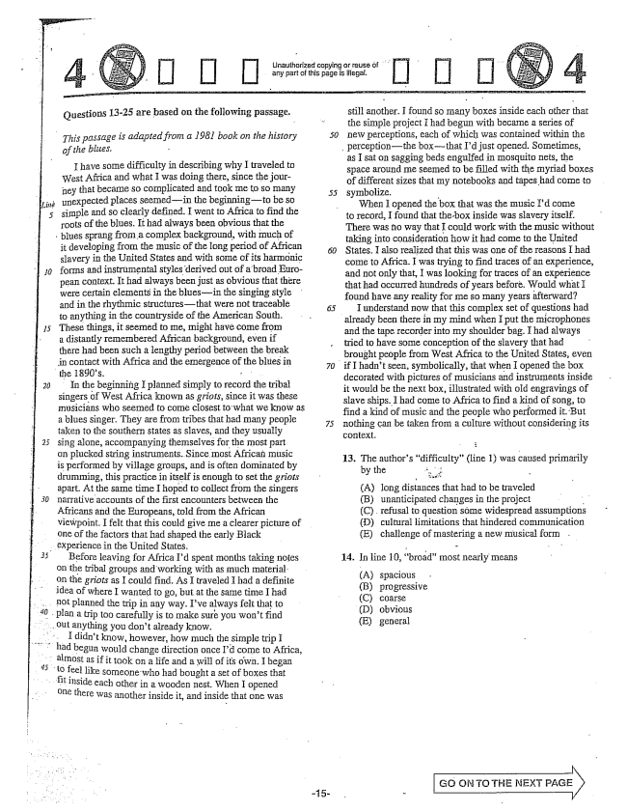

*20*

Questions 13-25 are based on the following passage.

*This passage is adapted from a 1981 book on the history*

*of the blites.*

I have some difficulty in describing why I traveled to West Africa and what I was doing there, since the journey that became so complicated and took me to so many unexpected places seemedin the beginningto be so simple and so clearly defined. I went to Africa to find the roots of the blues. It had always been obvious that the

blues sprang from a complex background, with much of

it developing from the music of the long period of African slavery in the United States and with some of its harmonic forms and instrumental styles derived out of abroad European context. It had always been just as obvious that there were certain elements in the bluesin the singing style and in the rhythmic structuresthat were not traceable to anything in the countryside of the American South. These things, it seemed to me, might have come from a distantly remembered African background, even if there had been such a lengthy period between the break

in contact with Africa and the emergence of the blues in the 1890s.

In the beginning I planned simply to record the tribal Singers of West Africa known as griots, since it was these musicians who seemed to come closest to what we know as a blues singer. They are from tribes that had many people taken to the southern states as slaves, and they usually sing alone, accompanying themselves for the most part on plucked string instruments. Since most Africań music is performed by village groups, and is often dominated by drumming, this practice in itself is enough to set the griots apart. At the same time I hoped to collect from the singers narrative accounts of the first encounters between the Africans and the Europeans, told from the African viewpoint. I felt that this could give me a clearer picture of One of the factors that had shaped the early Black experience in the United States.

Before leaving for Africa Id spent months taking notes

on the tribal groups and working with as much material. on the griots as I could find. As I traveled I had a definite

idea of where I wanted to go, but at the same time I had not planned the trip in any way. Ive always felt that to Plan a trip too carefully is to make sure you wont find out anything you don't already know.

I didn't know, however, how much the simple trip I

had begun would change direction once Id come to Africa, almost as if it took on a life and a will of its own. I began

to feel like someone who had bought a set of boxes that

inside each other in a wooden nest when I opened

**- - - -**

there was another inside it, and inside that one was

Unauthorized copying or reuse of " any part of this page is .

*50*

still another. I found so Imany boxes inside each other that the simple project I had begun with became a series of new perceptions, each of which was contained within the

perceptionthe boxthat Id just opened. Sometimes,

as I sat on sagging beds engulfed in Imosquito nets, the space around me seemed to be filled with the myriad boxes of different sizes that my notebooks and tapes had come to symbolize. -

When I opened the box that was the music Id come

to record, I found that the box inside was slavery itself.

There was no way that I could work with the music without taking into consideration how it had come to the United States. I also realized that this was one of the reasons I had come to Africa. I was trying to find traces of an experience, and not only that, I was looking for traces of an experience that had occurred hundreds of years before. Would what I found have any reality for me so many years afterward?

I understand now that this complex set of questions had already been there in my mind when I put the microphones and the tape recorder into my shoulder bag. I had always tried to have some conception of the slavery that had brought people from West Africa to the United States, even

if I hadnt seen, symbolically, that when I opened the box

decorated with pictures of musicians and instruments inside it would be the next box, illustrated with old engravings of slave ships. I had come to Africa to find a kind of song, to find a kind of music and the people who performed it. But nothing can be taken from a culture without considering its

13. The authors difficulty” (line 1) was caused primarily

by the - 3

(A) long distances that had to be traveled (B) unanticipated changes in the project - C) refusal to question some widespread assumptions (HD) cultural limitations that hindered communication (E) challenge of mastering a new musical form .

14. In iime 10, broad" rnostnearly meaTIS

(A) spacious (B) progressive (C) coarse (D) obvious (E) general

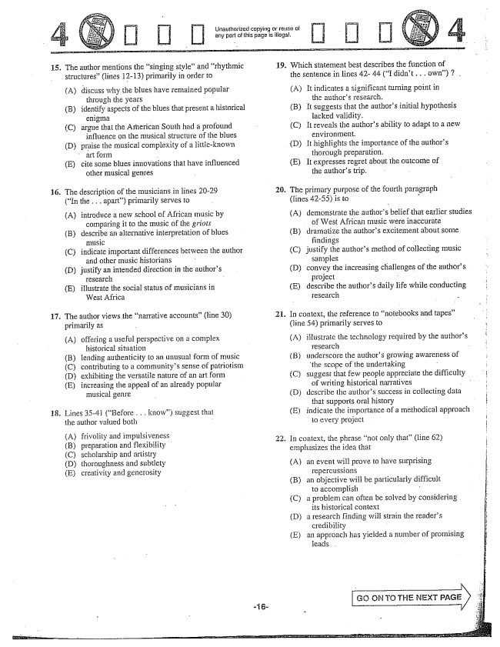

Unaulhorized copying or reuse of any part of this page is illegal. -

15. The author mentions the singing style” and rhythmic

structures” (lines 12-13) primarily in order to

(A) discuss why the blues have remained popular

through the years

(B) identify aspects of the blues that present a historical

enigma

(C) argue that the American South had a profound

influence on the Triusical structure of the blues

(D) praise the musical complexity of a littleknown

art form

(E) cite some blues innovations that have influenced

other musical genres

16. The description of the musicians in lines 20-29

(In the . . . apart) primarily Serves to

(A) introduce a new school of African music by

comparing it to the music of the griots

(B) describe an alternative interpretation of blues

music

(C) indicate important differences between the author

and other music historians

(D) justify an intended direction in the authors

research

(E) illustrate the social status of musicians in

West Africa

17. The author views the narrative accounts” (line 30)

primarily as

(A) offering a useful perspective on a complex

historical situation

(B) lending authenticity to an unusual form of music

(C) contributing to a communitys sense of patriotism

(D) exhibiting the versatile nature of an art form

(E) increasing the appeal of an already popular

musical genre

18. Lines 35-41 (Before . . . know) suggest that the author wafued both

A) frivolity and ifnpulsiveness (B) preparation and flexibility (C) scholarship and artistry (D) thoroughness and subtlety (E) creativity and generosity

-16

. In context, the phrase not only that(line 62)

19. Which statement best describes the function of

the sentence in lines 42-44 (I didn't. . . own) 2 .

(A) It indicates a significant turning point in

the authors research.

(B) It suggests that the authors initial hypothesis tacked validity. -

(C) It reveals the authors ability to adapt to a new

environment.

(D) It highlights the importance of the authors

thorough preparation.

(E) It expresses regret about the outcome of

the authors trip.

. The primary purpose of the fourth paragraph

(lines 4255) is to

(A) demonstrate the authors belief that earlier studies

of West African Imusic were inaccurate (B) dramatize the authors excitement about some

findings - (C) justify the authors method of collecting music

samples (D) convey the increasing challenges of the authors

project - E) describe the authors daily life while conducting | research -

. In context, the reference to notebooks and tapes”

(line 54) primarily serves to

(A) illustrate the technology required by the authors

research -

(B) underscore the authors growing awareness of

the scope of the undertaking

(C) suggest that few people appreciate the difficulty

of writing historical narratives . . . . .

(D) describe the authors success in collecting data

that supports oral history |

(E) indicate the importance of a methodical approach

lo every project

emphasizes the idea that

Aan event will prove to have surprising

Tepercussions (B) an objective will be particularly difficult to accomplish - (C) a problem can often be solved by considering

its historical context - (D) a research finding will strain the readers ;

credibility (E) an approach has yielded a number of promising i

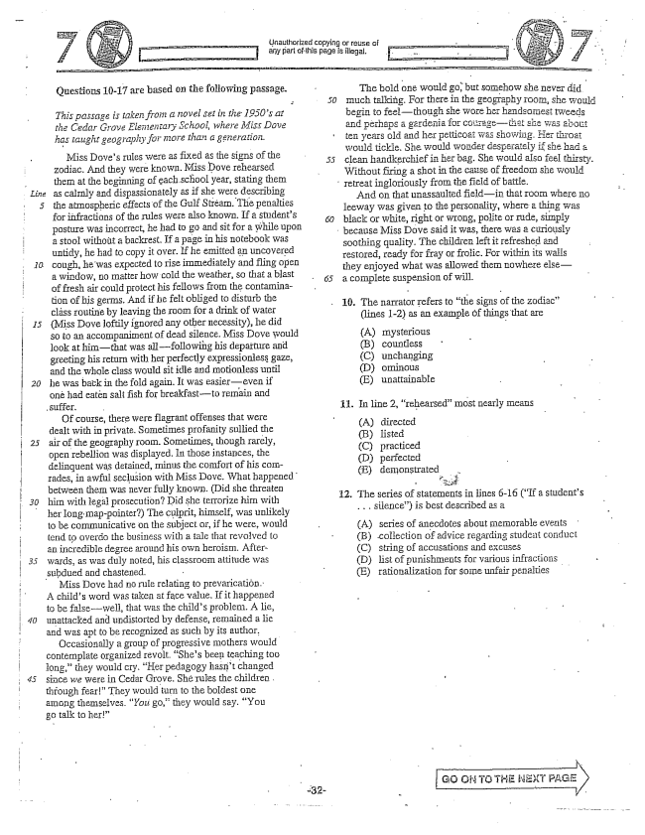

*20*

Questions 10-17 are based on the following passage.

*This passage is taken from a novel set in the 1950s at the Cedar Grove Elementary School, where Miss Dave has taught geography for more than a generation.*

Miss Doves rules were as fixed as the signs of the zodiac. And they were known, Miss Dove rehearsed them at the beginning of each School year, stating them as calmly and dispassionately as if she were describing the atmospheric effects of the Gulf Stream. The penalties for infractions of the rules were also known. If a students posture was incorrect, he had to go and sit for a while upon a stool without a backrest. If a page in his notebook was untidy, he had to copy it over. If he emitted an uncovered Cough, he was expected to rise immediately and fling open a window, Lo matter how cold the weather, so that a blast of fresh air could protect his fellows from the contamination of his germs. And if he felt obliged to disturb the cláss routine by leaving the room for a drink of water (Miss Dove loftily ignored any other necessity), he did so to an accompaniinent of dead silence. Miss Dove would look at himthat was allfollowing his departure and greeting his return with her perfectly expressionless gaze, and the whole class would sit idle and motionless until he was back in the fold again. It was easiereven if one had eaten salt fish for breakfastto remain and

Of course, there were flagrant offenses that were dealt with in private. Sometimes profanity Sullied the air of the geography room. Sometimes, though rarely, Open rebellion was displayed. In those instances, the delinquent was detained, minus the comfort of his comrades, in awful seclusion with Miss Dove. What happened between thern was never fully known. (Did she threaten him with legal prosecution? Did she terrorize him with her long map-pointer) The culprit, himself, was unlikely to be communicative on the Subject Or, if he were, would tend to overdo the business with a tale that revolved to an incredible degree around his own heroism. Afterwards, as was duly noted, his classroom attitude was

subdued and chastened.

Miss Dove had no rule relating to prevaricatión. A childs word was taken at face value. If it happened to be false-well, that was the childs problem. A lie, unattacked and undistorted by defense, remained a lie and was apt to be recognized as such by its author,

Occasionally a group of progressive mothers would contemplate organized revolt. Shes been teaching too long,they would cry, Her pedagogy hasn't changed since we were in Cedar Grove. She rules the children through fear" They would turn to the boldest one among themselves. "You go,they would say, You go talk to her”

triauthorized copying or reuse of any part ofihis page is ilegal.

The bold one would go, but somehow she never did much talking. For there in the geography roorn, she would begin to feelthough she wore her handsorpest tweeds and përhaps a gardenia for cGMPagethat she was about ten years old and her petticoat was showing. Her throat would tickle. She would worlder desperately if she had a clean handkerchief in her bag. She would also feel thirsty. Without firing a shot in the cause of freedom she would

Têtreatingloriously from the field of Battle.

And on that unassaulted fieldin that Toom where no Jeeway was given to the personality, where a thing was black or white, right or wrong, polité OT Iude, simply

because Miss Dove said it was, there was a curiously

soothing quality. The children left it refreshed and restoTed, ready for fray oI frolic. FOI within its walls they enjoyed what was allowed them nowhere elsea complete suspension of will.

10. The narrator refers to the signs of the zodiac" (lines 1-2) as an example of things that are

(A) (B) (C) (D) (E)

In line 2, rehearsed” most nearly means

mysterious countless unchanging ominOus unattainable

**11.**

(A) directed

(B) lísted

(C) practiced

(D) perfected

(E) demonstrated .

The series of statements in iines 16 (If a students . . . silence) is best described as a

(A) series of anecdotes about memorable events (B) collection of advice regarding student conduct (C) String of accusations and excuses (D) Hist of punishments for various infractions (E) rationalization for some unfair penalties

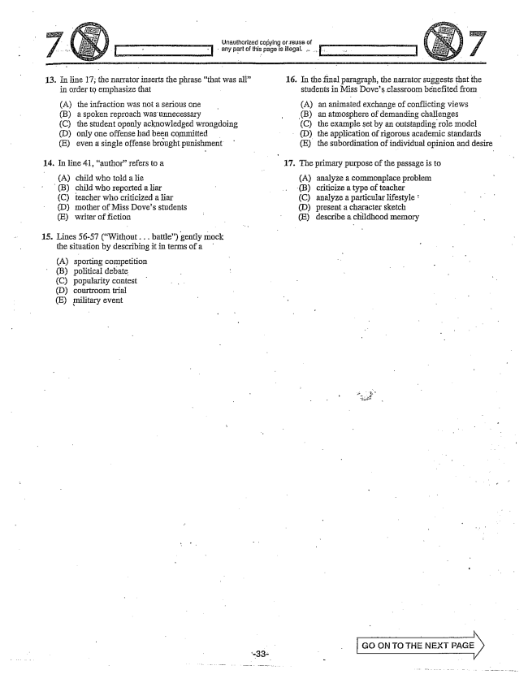

any part of this page is illegal. ..,

16. In the final paragraph, the narrator suggests that the

13. In line 17; the narrator inserts the phrase that was all”

students in Miss Doves classroom běnefited from

in order to emphasize that

Aan animated exchange of conflicting views (B) an atmosphere of demanding challenges (C) the example set by an outstanding role model

(D) the application of rigorous academic standards (E) the subordination of individual opinion and desire

(A) the infraction was not a serious one (B) a spoken reproach was unnecessary (C) the student openly acknowledged wrongdoing (D) only one offense had been committed (E) even a single offense brought punishment

17. The primary purpose of the passage is to

(A) analyze a commonplace problem - B) criticize a type of teacher (C) teacher who criticized a liar (C) analyze a particular lifestyle

(D) Inother of Miss Doves students . (D) present a character sketch (E) writer of fiction - - E) describe a childhood memory

14. In line 41, authorrefers to a

(A) child who a îie (B) child who reported a liar

**15**

Lines 56-57 (Without... battle) gently mock the situation by describing it in terms of a

(A) sporting competition (B) political debate (C) popularity contest (D) courtroom trial (E) military event

- GO ON TO THE NEXT PAGE X -

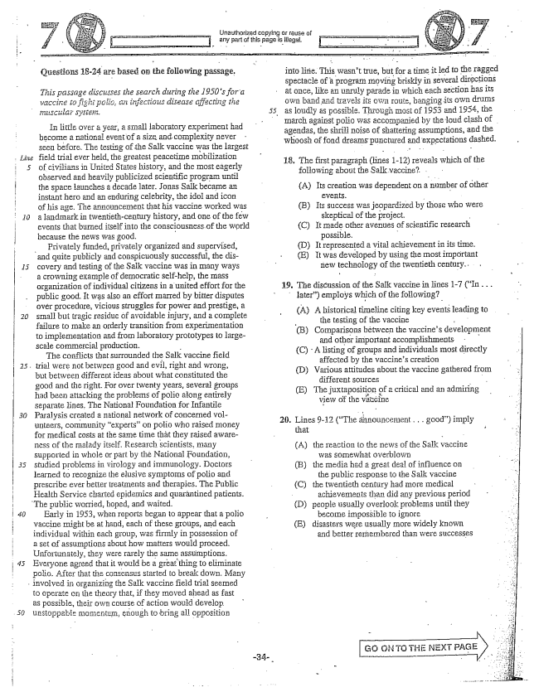

*20*

*30*

Questions 18-24 are based on the following passage,

*This passage discusses the search during the 1950s for a vaccine io fight polic, an infectiolis disease affecting the*

III little over a year, a SIHall laboratory experiment had become a national event of a size and complexity never seen before. The testing of the Salk vaccine was the largest field trial ever held, the greatest peacetime mobilization of civilians in United States history, and the most eagerly observed and heavily publicized Scientific program until the space iaunches a decade later. Jonas Salk became an instant hero and an enduring celebrity, the idol and icon of his age. The announcement that his vaccine worked was a landmark in twentieth-century history, and one of the few events that burned itself into the consciousness.of the world because the news was good. - .

Privately funded, privately organized and supervised,

and quite publicly and conspicuously successful, the dis

covery and testing of the Salk vaccine was in Imany ways a crowning example of democratic Self-help, the mass organization of individual citizens in a united effort for the public good. It was also an effort Inaried by bitter disputes over procedure, vicious struggles for power and prestige, a Small but tragic residue avoidable injury, and a complete failure to make an orderly transition from experimentation to implementation and from laboratory prototypes to largescale commercial production.

The conflicts that Surrounded the Sak vaccine field

trial were not between good and evil, right and wrong,

but between different ideas about what constituted the good and the right. For over twenty years, several groups had been attacking the problems of polio along entirely separate lines. The National Foundation for Infantile Paralysis created a national network of concerned volunteers, community experts” on polio who raised money for medical costs at the same time that they raised awareness of the maiady itself. Research scientists, many Supported in whole or part by the National Foundation, Studied problems in virology and immunology. Doctors learned to recognize the elusive symptoms of polic and prescribe ever better treatinents and therapies. The Public Health Service charted epidemics and quarántined patients.

The public worried, hoped, and waited.

Early in 1953, when reports began to appear that a polio Vaccine might be at hand, each of these groups, and each individual within each group, was firmly in possession of a Set of assumptions about how matters would proceed. Unfortunately, they were rarely the same assumptions. Everyone agreed that it would be a great thing to eliminate Polio. After that the consensus started to break down. Many

involved in organizing the Salk vaccine field trial seemed

to operate on the theory that, if they moved ahead as fast as possible, their own course of action would develop unstoppable momentum, enough to bring all opposition

Unauthorized copying or reuse of ; any part of this page is illegal.

into line. This wasn't true, but for a time it led to the ragged spectacle of a program moving briskly in several directions at Once, like an unruly parade in which each section has its own band and travels its own route, banging its OWn drums as loudly as possible. Through Ingst of 1953 and 1954, the IIIarch against polic was accompanied by the loud clash of agendas, the shrifi noise of shattering assumptions, and the whoosh of fond dreams punctured and expectations dashed.

18. The first paragraph (lines 1-12) reveals which of th following about the Saik vaccine? .

(A) Its creation was dependent on a number of other

- - (B) Its success was jeopardized by those who were

skeptical of the project. - (C) It made other avenues of scientific research

possible. (D) It represented a vitaĩ achievementin its time. (E) It was developed by using the most important

new technology of the twentieth century.

The discussion of the Salk vaccine in lines 1-7 (In . . . later) employs which of the following?

(A) A historical timeline citing key events leading to

- the testing of the vaccine

(B) Comparisons between the vaccines development

and other important accomplishments -

(C) . A listing of groups and individuals most directly

affected by the vaccines creation

(D) Various attitudes about the vaccine gathered from

different sources

(E) The juxtaposition of a critical and an admiring

view of the vaccine

19.

Lines 9-12 (The announcement .. good) imply that

(A) the reaction to the news of the Salk vaccine

was somewhat Overblown

(B) the media had a great of influence on

the public response to the Saik vaccine

(C) the twentieth century had more medical

- achievements than did any previous period

(D) people usually overlook problems until they

become impossible to ignore

(E) disasters were usually more widely known

and better fermembered than were successes

20.

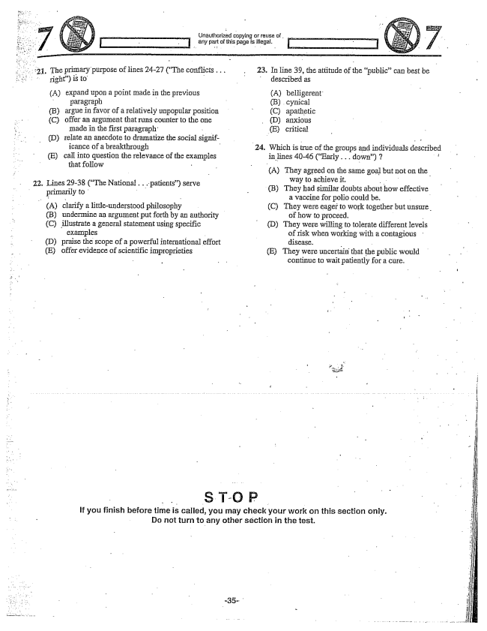

**21.**

22.

The primary purpose of lines 24-27 (The conflicts... right) is to - A) expand upon a point made in the previous

paragraph - B) argue in favor of a relatively unpopular position (C) offer an argument that runs counter to the one

made in the first paragraph: - D) relate an anecdote to dramatize the social significance of a breakthrough - E) call into question the relevance of the examples

that follow -

Lines 29-38 (The National .. patients) serve

primarily to A) a littleunderstood philosophy

(B) undermine an argument put forth by an authority

(C) illustrate a general statement using specific

examples - - D) praise the scope of a powerful international effort

(E) offer evidence of scientific improprieties

**23.**

**Unauthorized copying**

any part of this page is illegal.

In line 39, the attitIIde of the publiccan best be - described as

(A) belligerent

(B) cynical (C) apathetic

(D) anxious

(E) critical

Which is true of the groups and individuals described in lines 40-46 (Early .. down) 7 i

(A) They agreed on the same goal but not on the

way to achieve it. (B) They had similar doubts about how effective

a vaccine for polio could be. - (C) They were eager to work together but unsure

of how to proceed. (D) They were willing to tolerate different levels

of risk when working with a contagious disease. - (E) They were uncertain that the public would

continue to wait patiently for a cure.

If you finish before time is called, you may check your work on this section only. Do not turn to any other section in the test.

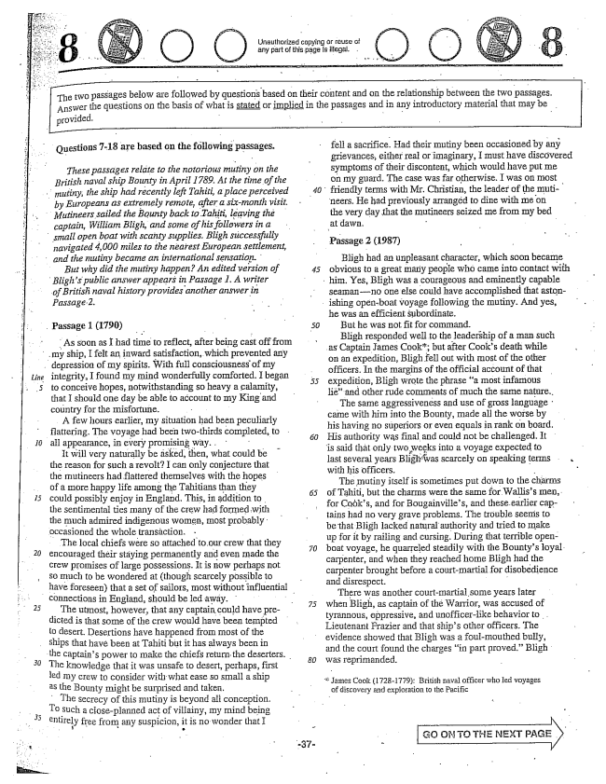

*Line*

*Aj*

25

the captains power to make the chiefs return the deserters.

*30*

Unauthorized cupying or reuse of any part of this page is illegal.

Answer the questions on the basis of wha provided. -

Questions -18 are based on the following passages.

*These passages relate to the notorious mutiny on the British naval ship Bourity in April 1789. At the time of the mutiny, the ship had recently left Tahiti, a place perceived by Europeans as extremely remote, after a six-month visit. Mutineers sailed the Baunty back to Tahiti, leaving the captain, William Bligh, and some of his followers in a small open boat with scanty supplies. Bligh sticcessfully navigated ,000 miles to the nearest European settlement, and the mutiny became an international sensation.*

*But why did the mutiny happen? An edited version of Blighs public answer appears in Passage 1. A writer of British naval history provides another answer in Passage2.*

Passage 1 (1790)

As soon as I had time to reflect, after being castofffrom

my ship, I felt an inward satisfaction, which prevented any

depression of my spirits. With full consciousness of my integrity, I found my mind wonderfully comforted. I began to conceive hopes, notwithstanding so heavy a calamity, that I should one day be able to account to Iny King and country for the misfortune. - -

A few hours earlier, my situation had been peculiarly flattering. The voyage had been twothirds completed, to all appearance, in every promising way. .

It will very naturally be asked, then, what could be the reason for such a revoltI can only conjecture that the mutineers had flattered themselves with the hopes of a more happy life among the Tahitians than they could possibly enjoy in England. This, in addition to . the sentimental ties many of the crew had formed with the much admired indigenous women, Inost probably Occasioned the whole transâction.

The local chiefs were so attached to our crew that they encouraged their staying permanently and even made the crew promises of large possessions. It is now perhaps not so much to be wondered at (though scarcely possible to

*40*

*50*

have foreseen) that a set of sailors, most without influential - -

connections in England, should be led away.

The utmost, however, that any captain could have predicted is that some of the crew would have been tempted to desert. Desertions have happened from most of the Ships that have been at Tahiti but it has always been in

The knowledge that it was unsafe to desert, perhaps, first led my crew to consider with what ease so small a ship as the Bounty might be surprised and taken,

The Secrecy of this mutiny is beyond all conception. 9 such a closeplanned act of villainy, my mind being entirely free from any suspicion, it is no wonder that I

at dawn.

The two passages below are followed by questions based on their content and on the relationship between the two passages.

tis stated or implied in the passages and in any introductory material that may be .

fell a sacrifice. Had their mutiny been occasioned by any grievances, either real or imaginary, I must have discovered symptoms of their discontent, which would have put me on my guard. The case was far otherwise. I was on most friendly terms with Mr. Christian, the leader of the mutineers. He had previously arrangëd to dine with the very day that the mutineers seized me from Iny bed

Passage 2 (1987)

Bligh had an unpleasant character, which soon became obvious to a great many people who came into contact with

him. Yes, Bligh was a courageous and eminently capable

seamanno one else could have accomplished that astonishing openboat voyage following the mutiny. And yes, he was an efficient subordinate.

But he was not fit for command. Bligh responded well to the leadership of a man such as Captain James Cook; but after Cooks death while on an expedition, Blighfell out with most of the other officers. In the margins of the official account of that expedition, Bligh wrote the phrase a most infamous lié" and other rude comments of much the same nature.

The same aggressiveness and use of gross language came with him into the Bounty, made all the worse by his having no superiors or even equals in rank on board. His authority was final and could not be challenged. It is said that only two into a voyage expected to last several years Blighwas scarcely on speaking terms with his officers, -

The mutiny itself is sometimes put down to the charms of Tahiti, but the charms were the same for Walliss men, for Coöks, and for Bougainvilles, and these earlier captains had no very grave problems. The trouble seemis to be that Bligh lacked natural authority and tried to make up for it by railing and cursing. During that terrible openboat voyage, he quarreled steadily with the Bountys loyal carpenter, and when they reached home Bligh had the carpenter brought before a court-martial for disobedience and disrespect. -

There was another courtmartial some years later when Bligh, as captain of the Warrior, was accused of tyrannous, oppressive, and unofficerlike behavior to . . Lieutenant Frazier and that ships other officers. The evidence showed that Bligh was a foulmouthed bully, and the court found the charges in part proved.” Bligh was reprimanded.

James Cook (17281779): British naval officer who fed voyages

of discovery and exploration to the Pacific

go on. To THE NEXT PAGE X

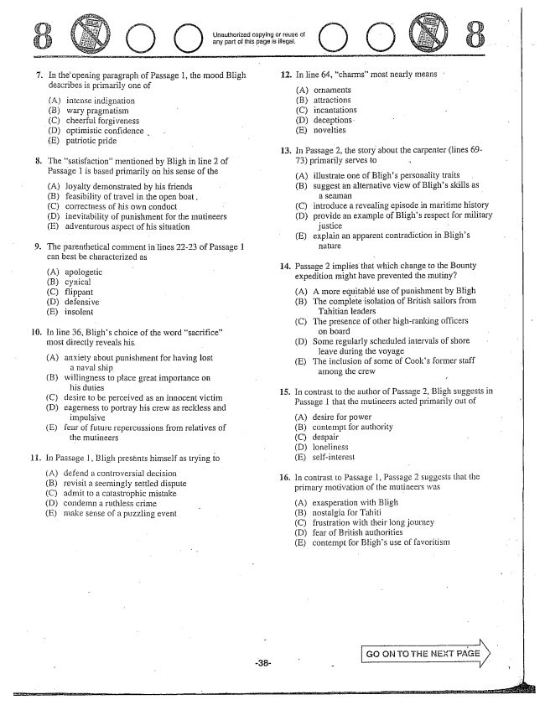

Unauthorized copying or reuse of any part of this page is illegal,

. In the opening paragraph of Passage 1, the mood Bligh 12. In line 64, chairms” Inost nearly means

describes is primarily one of -

A) ornaments

(A) intense indignation (B) attractions (B) wary pragmatism - C) incantations (C) cheerful forgiveness (D) deceptions. (D) optimistic confidence . . - E) novelties

(E) patriotic pride - -

13. In Passage 2, the story about the carpenter (lines 69

8. The satisfaction” mentioned by Bligh in line 2 of 73) primarily serves to

Passage 1 is based primarily on his sense of the (A) illustrate one of Blighs personality traits (A) loyalty demonstrated by his friends (B) suggest an alternative view of Blighs skills as (B) feasibility of travel in the open boat, - C) correctness of his own conduct (C) introduce a revealing episode in maritime history (D) inevitability of punishment for the mutineers (D) provide an example of Blighs respect for military (E) adventurous aspect of his situation justice -

- - (E) explain an apparent contradiction in Blighs 9. The parenthetical comment in lines 22-23 of Passage 1

can best be characterized as -

14. Passage 2 implies that which change to the Bounty

expedition might have prevented the mutiny? (C) flippant (A) A more equitablé use of punishment by Bligh (D) defensive: (B) The complete isolation of British Sailors from (E) irIsolent Tahitian leaders -

- - (C) The presence of other highranking officers 10. In line 36, Blighs choice of the word sacrifice” on board

most directly reveals his - (D) Some regularly scheduled intervals of shore

- - - leave during the voyage punishment for having lost (E) The inclusion of some of Cooks former Staff - --- - - among the crew (B) willingness to place great importance on

his duties 15. In contrast to the author of Passage 2, Bligh suggests in (C) desire to be perceived as an innocent victim - I if - s -f (D) eagerness to portray his crew as reckless and assage I that the mutineers acted primarily out D

impulsive - A) desire for power (E) fear of future repercussions from relatives of - B) contempt for authority

the mutineers (C) despair

(D) loneliness 11. In Passage I, Bligh presents himself as trying to (E) self-interest

(A) controve decision . In contrast to Passage 1, Passage 2 suggests that the (B) revisit a seemingly settled dispute imary motivation of th (C) admit to a catastrophic mistake primary motivation of the mutineers was (D) condemn a ruthless crime - A) exasperation with Bligh (E) make sense of a puzzling event . (B) nostalgia for Tahiti

(C) frustration with their long journey (D) fear of British authorities (E) contempt for Blighs use of favoritism

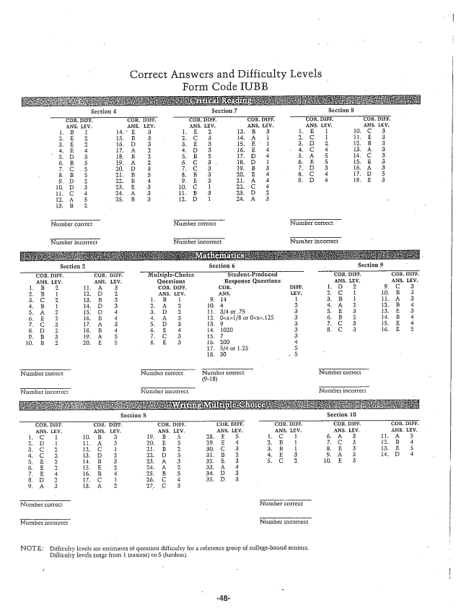

Correct Answers and Difficulty Levels

Form Code IUB

NOTE: Difficulty levels are estimates of question difficulty for a reference group of collegebound seniors.

Difficulty levels range from 1 (easiest) to 5 (hardest.